FIRST INFORMATION BROCHURE
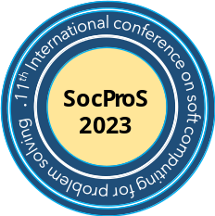

11th International Conference

On

Soft Computing for Problem Solving
Moving Towards Society 5.0

August 11-13, 2023

IIT ROORKEE
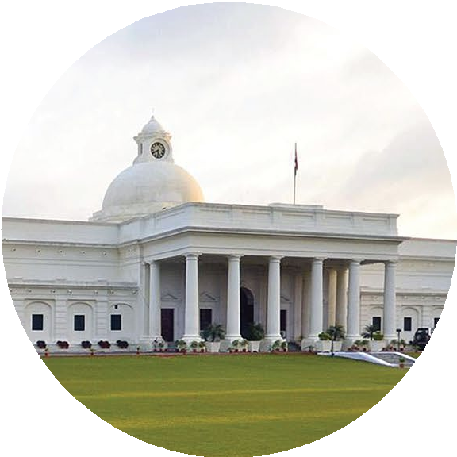

SOCPROS 2023
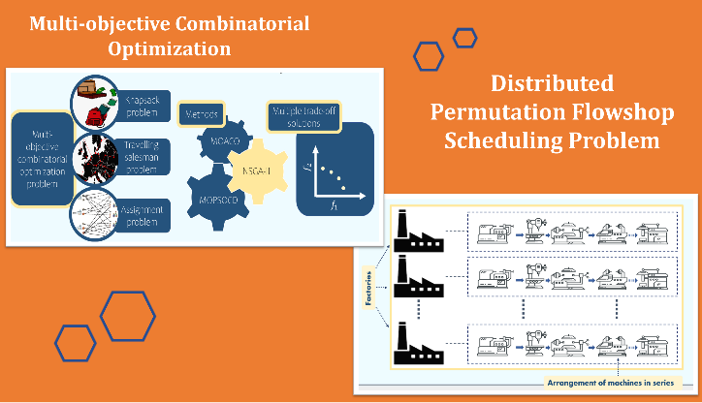
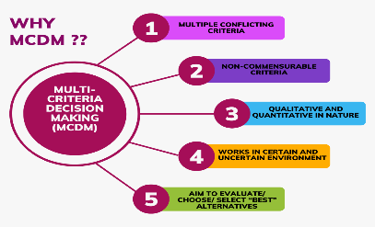
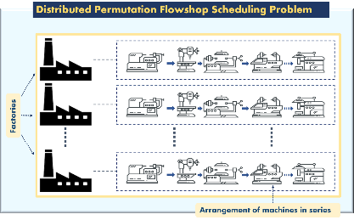
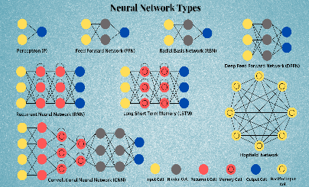
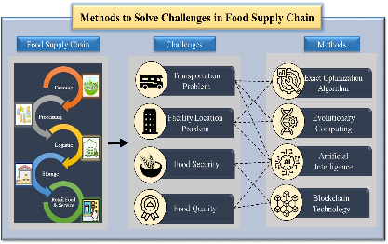
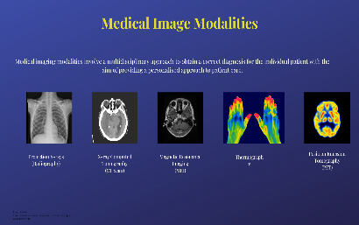

INVITATION

The organizing committee is delighted to invite you to participate in the International Conference on Soft Computing for problem-solving (SocProS 2023) to be held in physical mode organized by the Department of Applied Mathematics and Scientific Computing (D-AMSC), IIT Roorkee, India on August 11-13, 2023.
SocProS-2023will bring together leading Mathematicians, Scientists, Engineers, Research Scholars and Students under a common platform to interact and showcase various dimensions related to soft computing, machine learning and other AI techniques.

ABOUT IIT ROORKEE

Indian Institute of Technology - Roorkee is among the foremost of institutes of national importance in higher technological education and in engineering, basic and applied research. It has a history of more than 175 years. Since its establishment, the Institute has played a vital role in providing technical manpower and know-how to the country and in pursuit of research. The Institute ranks amongst the best technological institutions in the world and has contributed to all sectors of technological development. It has also been considered a trend-setter in the area of education and research in the field of science, technology, and engineering.

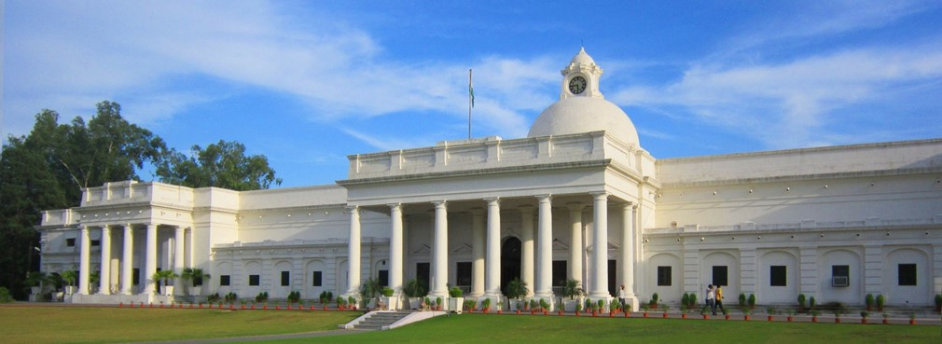ABOUT SAHARANPUR CAMPUS

Situated at the foothills of the enchanting lower Himalayan ranges of Shiwalik, the city of Saharanpur (Western Uttar Pradesh) is the home to another campus of IIT Roorkee, popularly known as its Saharanpur Campus. The campus started its journey in the year 1964 as School of Paper Technology established by the Government of India in 1964, with an aid from the Royal Swedish Government. The school was managed by a society created by the U.P. Government until its merger with the then University of Roorkee in 1978. The University of Roorkee was given the status of a University by Act No IX of 1948 of the United Provinces (Uttar Pradesh). It is now known as the Saharanpur Campus of IIT Roorkee.
Saharanpur Campus is a well-planned Campus spread over 25 acres of land and is at a distance of around 49 km from the Roorkee campus. The Saharanpur Campus presently has three departments: The Department of Paper Technology, The Department of Polymer Engineering and The Department of Applied Mathematics and Scientific Computing, the most recently established Department. The Departments offer M.Tech and Ph.D. degrees in different programs.

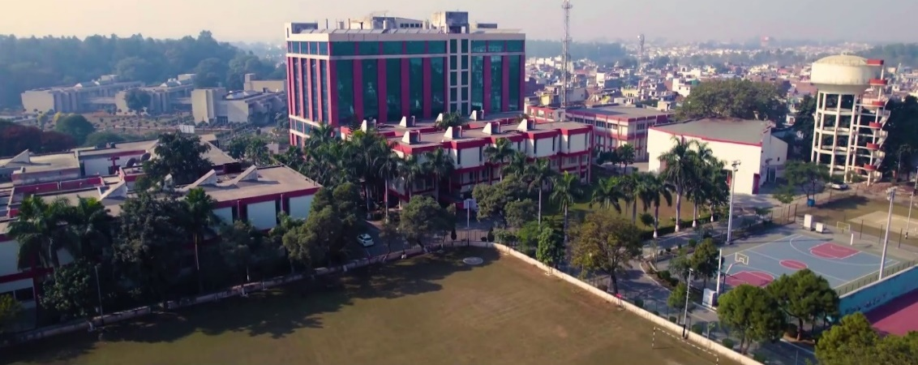

ABOUT THE DEPARTMENT (DAMSC)

The Department of Applied Mathematics and Scientific Computing (D-AMSC), is one of the most recent departments of IITR, came into existence in March 2022. The objective of the Department is to train the students in efficient computational techniques, which are often desirable and are many times necessary for solving complex real-world problems where analytical approaches are either difficult or impossible to use. The area of specialization of the faculty at D-AMSC includes numerical differential equations, numerical optimization, operations research, data science and machine learning and their applications to real life problems occurring in different domains. The department presently offers Ph.D. degree in Applied Mathematics and Scientific Computing and from 2023 onward, M.Tech degree will also be offered. At present around 30 Students are enrolled for the PhD degree at D-AMSC.

ABOUT THE CONFERENCE

SocProS was first held in 2011 at IIT Roorkee and attracted a large number of national and international researchers. Encouraged by its huge success, it was made a yearly event and the subsequent SocProS conferences were held in India and abroad with the last one being held at IIT Mandi in 2022. SocProS 2023, the 11th event of this flagship conference will be held at IIT Roorkee.

THEME OF THE CONFERENCE

The term Soft Computing represents a collection or set of computational techniques in machine learning, computer science and some engineering disciplines, which investigate, simulate, and analyze very complex issues and phenomena. SocProS23 aims to bring together researchers, engineers and practitioners to present the latest achievements and innovations in the interdisciplinary areas of soft computing, to discuss thought-provoking developments and challenges, and to consider potential future directions. One of the objectives of the conference is to encourage participation by young researchers; to this end, student papers will be given special consideration.

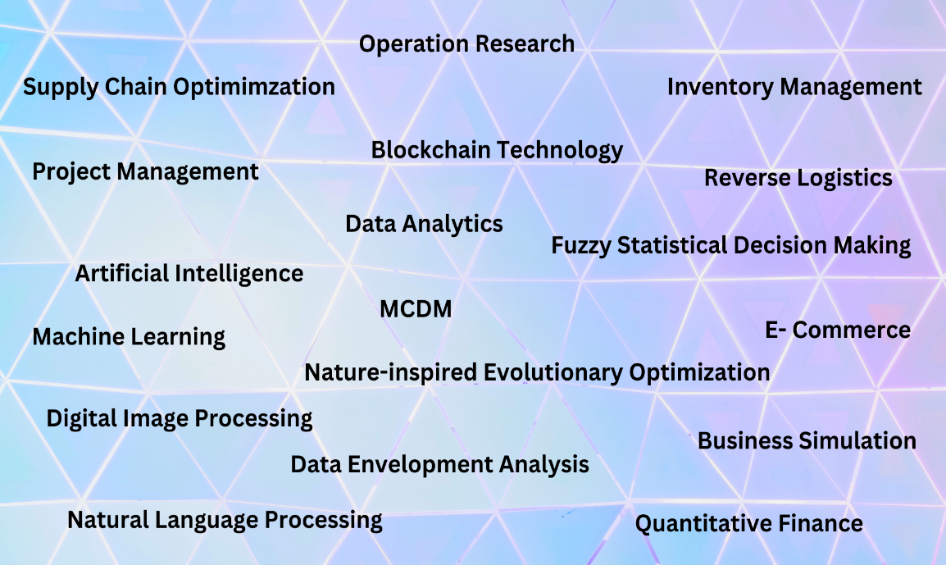

CALL FOR PAPERS

The 11th International Conference on Soft Computing for Problem Solving is an interdisciplinary conference that aims to bring together researchers working in different areas of Soft Computing, Machine Learning and Artificial Intelligence.
Contributions are welcomed on all areas related to soft computing techniques like evolutionary and nature inspired algorithms, swarm intelligence algorithms, fuzzy systems in terms of theoretical development and applications in different domains.
Contributions are particularly solicited on this year’s theme, which include applications of soft-computing, AI and ML on the areas of: Healthcare, Agriculture, Defence, Supply Chain Management and Logistics, Smart Cities and other applications relevant to the theme of the conference.
All papers will be reviewed in a double-blind process and accepted papers will be presented at the conference.

PROCEEDINGS

To be published in Springer (pending approval).

IMPORTANT DATES

Deadline for paper submission | March 01, 2023
Decision of Acceptance | April 15, 2023
Camera ready papers & registration | June 15, 2023

REGISTRATION FEE

Registration fee includes conference proceedings published by Springer, conference bag, breakfast and lunch on all three days and gala dinner. Limited accommodation will be arranged on first-cum-first serve basis. One registration will cover only one paper of 10 pages. Additional papers by the same author(s) will be charged separately.

Registration
Category | Indian Author | Foreign Author
Full time student author | Rs 4500 | USD 300
Regular author | Rs 7000 | USD 500
Extra paper charges | Rs 4500/paper | USD 200/paper
Extra page charges  Only attending | Rs 2000/page  Rs.2000 | USD 100/page  USD 100

REGISTRATION – To be done online (Registration link)

SUBMISSION OF PAPERS – Please submit your original research paper using Easychair.

ORGANIZING COMMITTEE

Organizing committee | Name of committee members | Affilation
Patron | Prof. KK Pant,  Director | IIT Roorkee, India
Conference Chair | Prof. Millie Pant  Head, Department of Applied Mathematics and Scientific Computing | IIT Roorkee, India
Honorary Chair | Dr. Chander Mohan  Retd. Professor | IIT Roorkee, India
Conveners | Prof. Kusum Deep | IIT Roorkee, India
Conveners | Prof Atulya Nagar | Liverpool Hope, United Kingdom
Organizing Secretaries | Prof. Rajan Arora | IIT Roorkee, India
Organizing Secretaries | Prof. Manoj Thakur | IIT Mandi, India
Treasurers | Prof. Millie Pant | IIT Roorkee, India
Treasurers | Prof. Kusum Deep | IIT Roorkee, India
Best Paper Chairs | Prof Atulya Nagar, UK | Liverpool Hope, United Kingdom
Best PhD Thesis Chairs | Prof Atulya Nagar | Liverpool Hope, United Kingdom
Best PhD Thesis Chairs | Prof. AK Verma | Western Norway University of Applied Sciences, Norway
Publicity Chairs | Dr. Musrrat Ali | King Faisal University, Kingdom of Saudi Arabia
Publicity Chairs | Dr. Shilpa Shrivastava | Christ University, India
Publicity Chairs | Dr. Meenu Singh | VSB- Technical University of Ostrava, Czech Republic
Publicity Chairs | Dr. Kamanasish Bhattacharjee | Mayo Clinic, Arizona, USA
Publicity Chairs | Dr. Bilal | UTSW Medical Center, Dallas, USA
Publicity Chairs | Dr. Neetu Kushwaha | The Alan Turing Institute, London, UK
Conference Proceeding Chairs | Prof. Millie Pant | IIT Roorkee, India
Conference Proceeding Chairs | Prof. Kusum Deep | IIT Roorkee, India
Technical Sessions Chair | Dr. Irshad Ansari | IIITDM, Jabalpur, India
Technical Sessions Chair | Dr. Sunil Jauhar | IIM Kashipur, India
Technical Sessions Chair | Dr. Manoj Thakur | IIT Mandi, India
Special Session Chair | Dr. Musrrat Ali | King Faisal University, Kingdom of Saudi Arabia
Special Session Chair | Dr. Sushil Kumar | NIT Kurukshetra, India
Special Session Chair | Dr. Irshad Ansari | IIITDM, Jabalpur, India
Special Session Chair | Dr. Natthan Singh | IET Lucknow, India
Hospitality Chair | Dr. Anurag Kushreshtra | IIT Roorkee, India
Reception & Registration Chair | Dr. Shilpa Shrivastava | Christ University, India
Reception & Registration Chair | Dr. Pinkey Chauhan | Jaypee Institute of Information Technology, India
Reception & Registration Chair | Dr. Hira Zaheer | Galgotias University, India
Printing & Publication Chair | Prof. Kusum Deep | IIT Roorkee, India
Cultural Program Chairs | Prof. Sampat Singh Bhati | IIT Roorkee, India

CONTACT DETAILS

Kusum Deep
Professor,
Department of Mathematics

kusum.deep@ma.iitr.ac.in
9837164078
Millie Pant
Professor,
Department of Applied Mathematics and Scientific Computing
pant.milli@as.iitr.ac.in
9759561464

Department of Applied Mathematics and Scientific Computing
Indian Institute of Technology Roorkee
Saharanpur Campus, Saharanpur, UP, India-247667

